Joli Ann Leichtag
Family Math Night

Come join us for an evening of engaging math activities! You and your TK-5 student will enjoy grappling, laughing, and learning together!
Date: Thursday, November 15th
Time: 5:30 - 7:00 p.m.
Where: Joli Ann Leichtag Elementary School
653 Poinsettia Ave, Vista

Bring your PAWS Passbook!

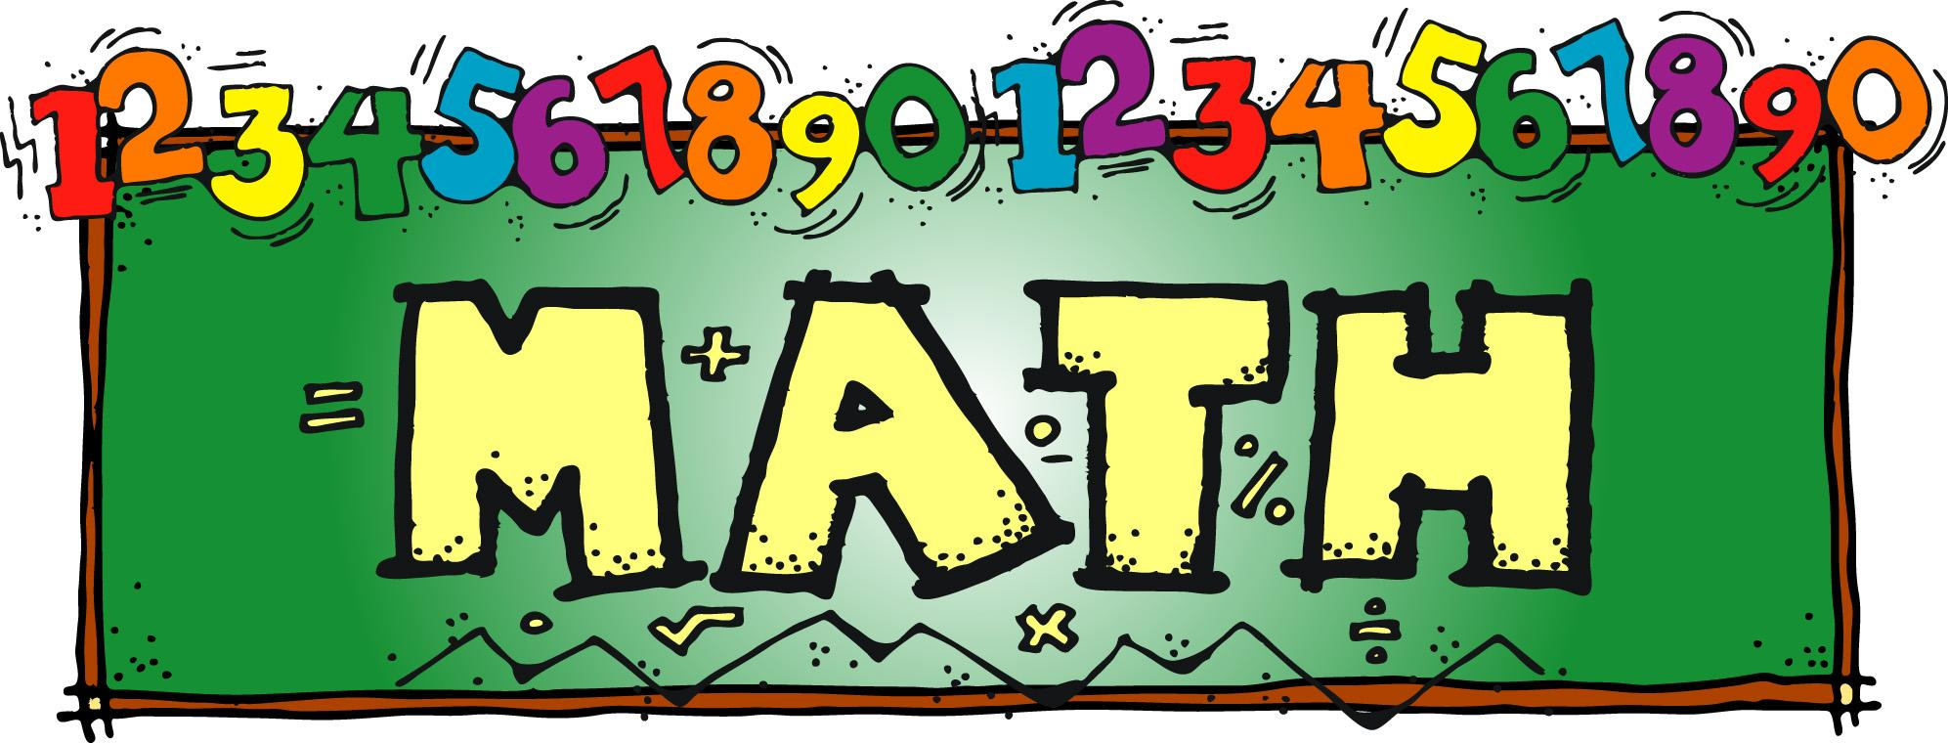

Parent first & last name: _____________________________________________

Grades of students: K-1 2-3 4-5

Names of students: _____________________________________________

*Please return to your child’s school by Tuesday, November 13th

